Control Flow Graph-Based Software Testing
- Based on the unit both the team and the instructor have agreed to, you are asked to find two more units with the SIMILAR structure.
For each unit, do the following tasks:
  - Show the source code with its location in the project source file.

# Progression logic
def progress(skill, passed, conn):
if passed:
next_code = skill["next"]
# Terminal node (at highest level)
if next_code == skill["code"]:
return None, "top"
return get_skill_set(conn, next_code), "advance"
else:
prev_code = skill["prev"]
# Already at the bottom
if prev_code == skill["code"]:
return skill, "remediate_same"
return get_skill_set(conn, prev_code), "remediate"

  - Show the Control Flow Graph (Check the CFG’s slides) (3pts). Each node or edge should have the corresponding line number to the code.

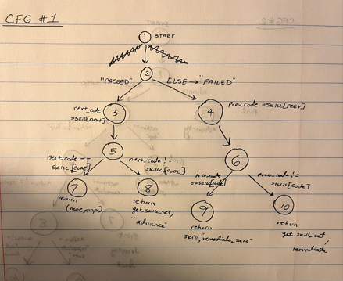
Node 1 – start node
Node 2 – if passed (condition)
Node 2-3: passed == true
Node 2-4: passed == false (else)
Node 3: next_code = skill[next]
Node 4: prev_code = skill[prev]
Node 5: if next_code == skill["code"]
Node 6: if prev_code == skill["code"]
Node 5-7: next_code == skill["code"]
Node 5-8: next_code != skill["code"]
Node 6-9: prev_code == skill["code"]
Node 6-10: prev_code != skill["code"]
Node 7: return None, “top”
Node 8: return get_skill_set(conn, next_code), "advance"
Node 9: return skill, "remediate_same"
Node 10: return get_skill_set(conn, prev_code), "remediate"

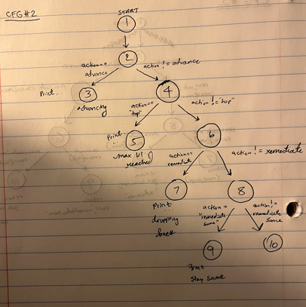
Node 1: start
Node 2 : if action == advance
Node 2-3: action == advance
Node 2-4: action != advance
Node 3: Print(…)…advancing
Node 4: if action == “top”
Node 4-5: action == “top”
Node 4-6: action != “top”
Node 5: print(“max level reached”)
Node 6: if action == “remediate”
Node 6-7: action == “remediate”
Node 6-8: action != “remediate”
Node 7: print(“dropping back”)
Node 8: if action == “remediate_same”
Node 8-9: action == “remediate_same”
Node 8-10: action != “remediate_same”
Node 9: print(“stay same”)
Node 10: END

  - Choose a graph coverage criterion to test the unit. Based on coverage criterion you choose, do the following items (7pts):
    - List a set of test requirements (using the CFG’s node and edge information as well as line number).
    - Apply a unit testing framework to generate a set of test cases. For each test case, show which test requirement is satisfied. Show the unit testing code for each test case.

See attached test.py file for unit test cases

